

**BAHRIA UNIVERSITY, (Karachi Campus)**

*Department of Software Engineering*

PROPOSAL

**Course Title: Software Design & Architecture Course Code**:

**Course Instructor: Engr. Ramsha Mashood Class**: BSE- 4A

**Lab Instructor:** Engr. Asma Shaheen  **Name: Syed Fahad Ali Gillani**

PROJECT TITLE:

**Expense Tracker**

GROUP MEMBERS LIST:

|  |  |  |
| --- | --- | --- |
| Enrollment | Name | Email |
| 02-131222-083 | Syed Fahad Ali Gillani | fahadgillani08@gmail.com |

Submission Date**:** 3/05/2024

Table of Contents

1. INTRODUCTION: 3

2. ABSTRACT: 3

3. PROJECT SCOPE: 3

4. PROJECT FUNCTIONALITIES: 4

5. ASSUMPTIONS AND CONSTRAINTS: 4

6. UML DIAGRAMS (FLOW DIAGRAM, USE CASE, CLASS DIAGRAM, AND ENTITY RELATIONSHIP DIAGRAM) 5

7. PROJECT DELIVERABLES NOT CHANGEABLE 6

8. REFRENCES: 7

# **INTRODUCTION:**

Our lives are becoming increasingly complex, and with that comes the need for better financial management tools. In line with this, we propose to develop an Expense Tracker using ASP.NET C#. This system aims to provide users with a robust platform to track their expenses and incomes efficiently, facilitating informed decision-making and financial planning.

# **ABSTRACT:**

The Expense Tracker is a web-based application developed using ASP.NET C# that enables users to track their financial transactions conveniently. With features such as expense categorization, income tracking, and comprehensive reporting, the system empowers users to manage their finances effectively. By providing a user-friendly interface and robust data security measures, the system aims to simplify the process of financial management for individuals and businesses alike.

# **PROJECT SCOPE:**

The scope of the project includes the development of a fully functional web application that allows users to:

* Register and log in securely to their accounts.
* Manipulate expenses with customizable categories.
* Track various sources of income.
* View summarized reports of expenses and incomes.
* Implement role-based access control to manage user permissions.
* Ensure data security through encryption and secure authentication mechanisms.

# **PROJECT FUNCTIONALITIES:**

The Expense Tracker will include the following key functionalities:

* User Registration and Authentication: Secure user registration and login system to access the application.
* Expense Tracking: Ability to manipulate expenses with customizable categories and optional attachments.
* Income Tracking: Capability to manipulate different sources of income.
* Dashboard: Provide users with an overview of their financial status through summarized data.

# **ASSUMPTIONS AND CONSTRAINTS:**

**Assumptions:**

* Users will have a basic understanding of financial management principles.
* The application will be accessed using modern web browsers with stable internet connectivity.
* Users will input accurate and relevant financial data for effective tracking and analysis.

**Constraints:**

* Limited resources (time and manpower) may affect the project timeline and scope.
* Compatibility issues may arise with older web browsers or mobile devices.
* Data security and privacy concerns need to be addressed to ensure compliance with regulatory requirements.

# **UML DIAGRAMS (FLOW DIAGRAM, USE CASE, CLASS DIAGRAM, AND ENTITY RELATIONSHIP DIAGRAM)**

**FLOW DIAGRAM**

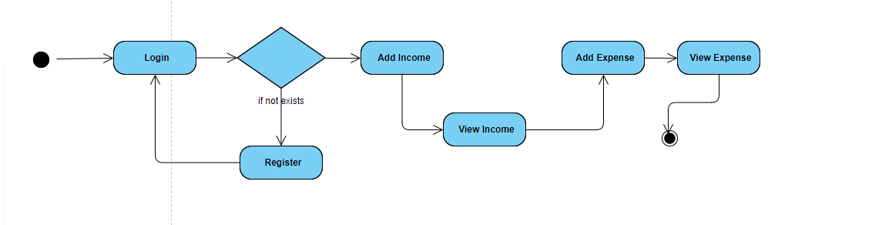

**USE CASE DIAGRAM**

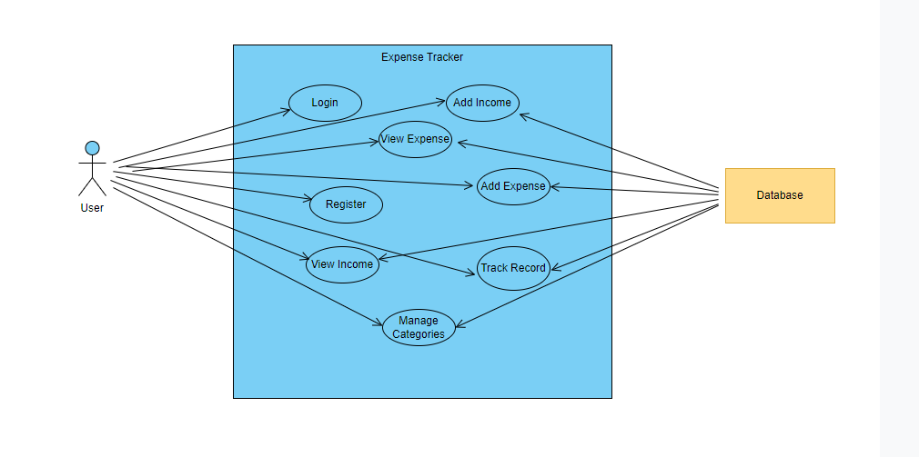

**CLASS DIAGRAM**

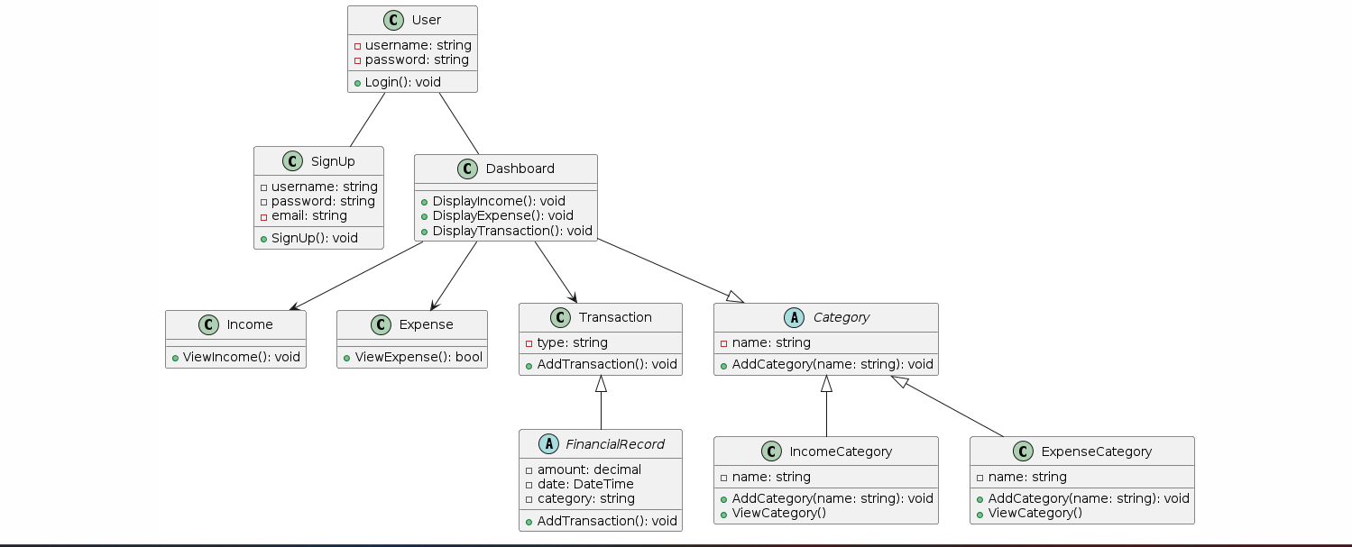

**ER-DIAGRAM**

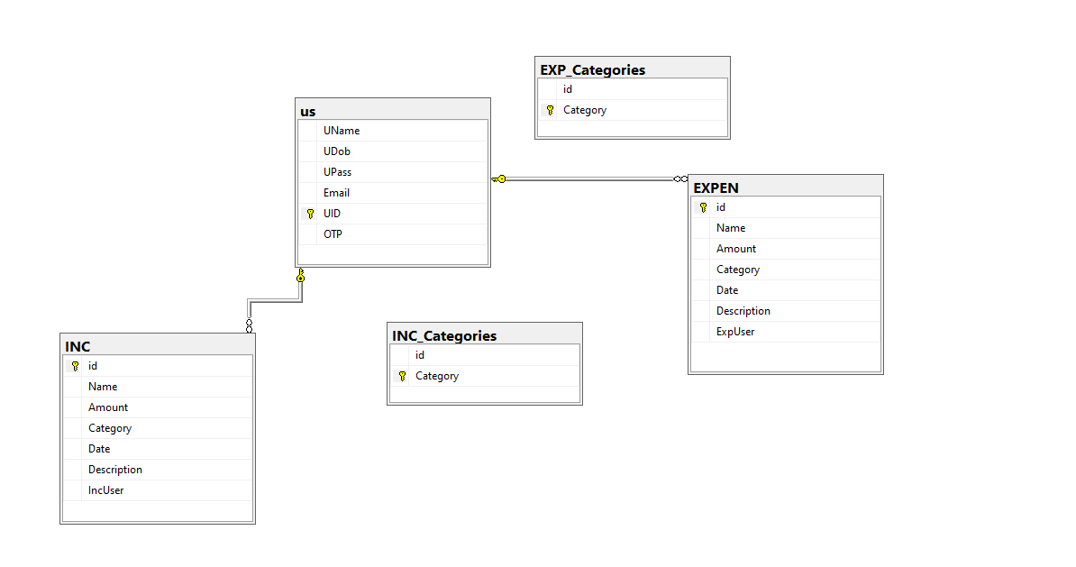

# **PROJECT DELIVERABLES NOT CHANGEABLE**

* Login screen for user authentication.
* Ability to register new user.
* Dashboard overview displaying financial report.
* Ability to add new expenses.
* Feature to add new income sources.
* Feature to view Income
* Feature to view expense.

# **REFRENCES:**

<https://www.volopay.com/expense-management/what-is-expense-management-software/>

<https://www.zoho.com/expense/articles/what-is-expense-management-software.html>

**Teacher Signature**: ______________________________________________

**Remarks**: ______________________________________________

**Submission Date**: ______________________________________________